Anthony Ventura

Linux Administration

Grep Lab

Print all lines containing the string Street .

grep ‘Street’ datebook

Print all lines where the person's first name starts with M.

grep ‘^M’ datebook

Explanation: this command would search for the beginning of the names. “^” it looks for the beginning of the line.

Print all lines ending in 000 .

grep ‘000$’ datebook

Explanation: this command would print all the 0’s at the end of the line. The dollar sign means to look for the end of the line or all the lines that end with 0

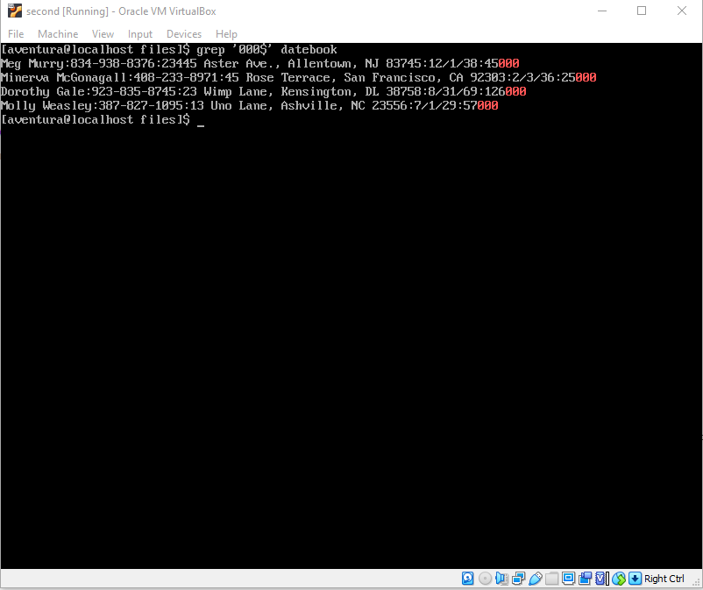

Print all lines that don't contain 408 .

grep -v -e ‘408’ datebook

Explanation: This command is asking to the system to print all the information that don’t contain 408. -v is telling the command to look for no matches of 408. -e searches for all the information given.

Print all lines where the phone number is in an area code that starts with an 8

grep -E :[8]’ datebook

Explanation: This command will print all the lines that starts with 8, -E represents as a extended regular expression.

Print all lines containing an uppercase letter, followed by 5 lowercase letters, a comma, and one uppercase letter.

grep ‘[A-Z][a-z]\{5\}, [A-Z]’ datebook

Explanation: This command tells to print all the lines that contains an uppercase and that would print 5 letters in lowercase with a comma and one uppercase at the end.

Print lines preceded by a line number where the person is from Massachusetts (or MA)

grep -n -e ‘Massachusetts’ -e ‘MA’ datebook

Explanation: This command will return addresses with two or three digits. “-e” searches of all the pattern given.

Print lines where the address begins with a two- or three-digit number (so this would be 12 main st or 123 main street but not 1234 main street).

grep -E ‘[[:digit:]]{2,3}\b’ datebook

Explanation: This command would look for addresses that would have two or three digits. The function of “-E” is to look for regular expressions.

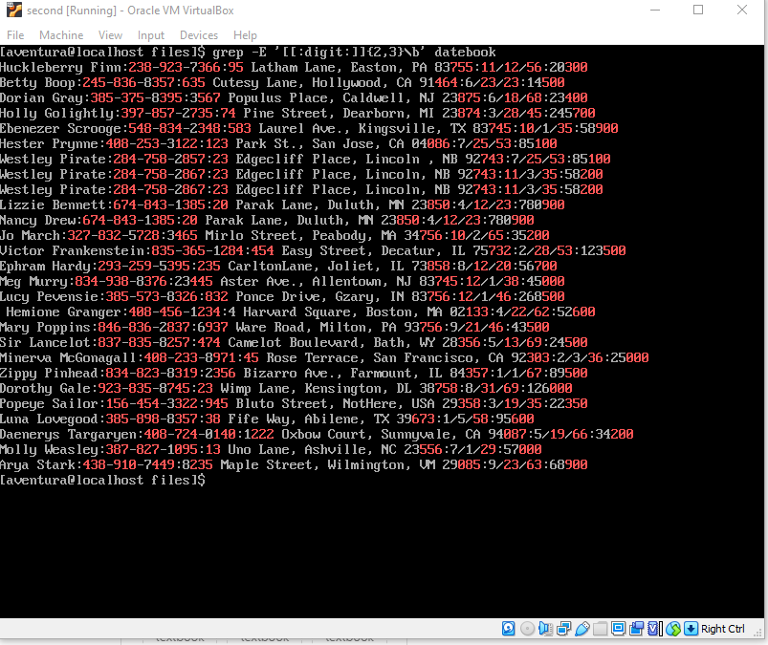

Sources:

<https://man7.org/linux/man-pages/man1/grep.1.html>

<https://flylib.com/books/en/4.356.1.25/1/>

<https://youtu.be/Iif-DjWYoWY>

<https://searchcode.com/codesearch/view/12092253/>